**Data upload using PIG**

Load Movies data into HIVE table:

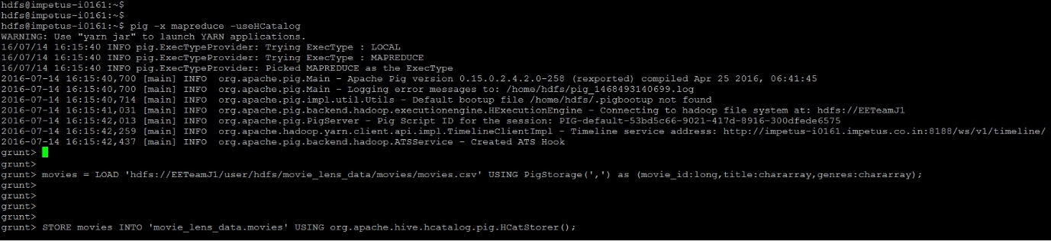

Movie data upload result:

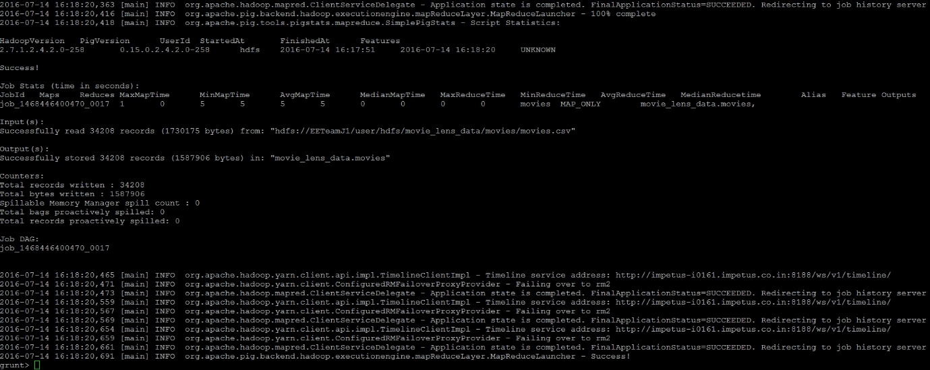

Load Ratings data into HIVE table:



Ratings data upload result:

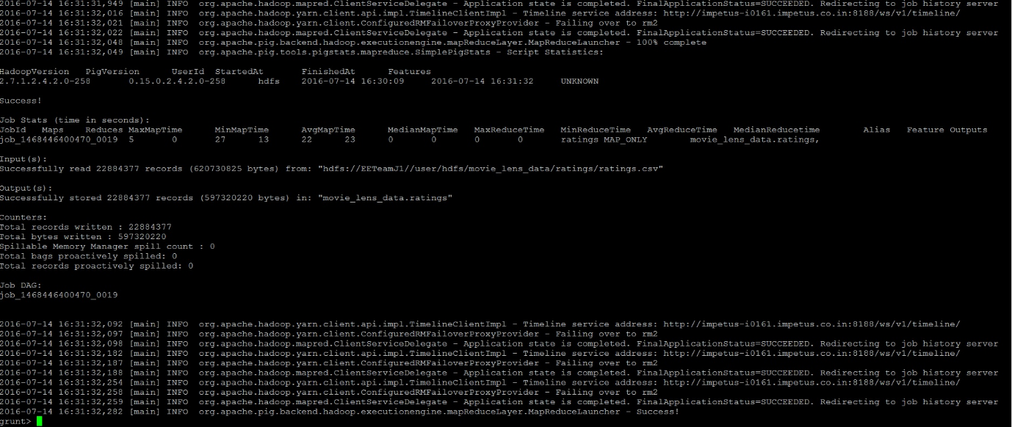

Load Users data into HIVE table:



Users data upload result:

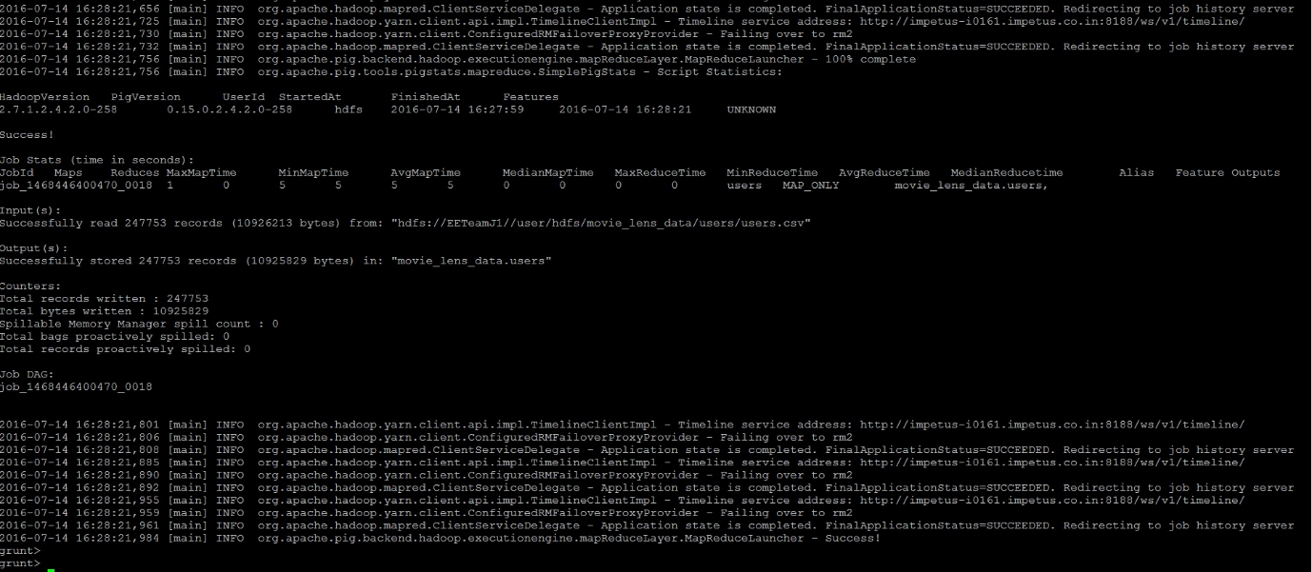

**HIVE Queries execution:**

**Create Database & Users table:**

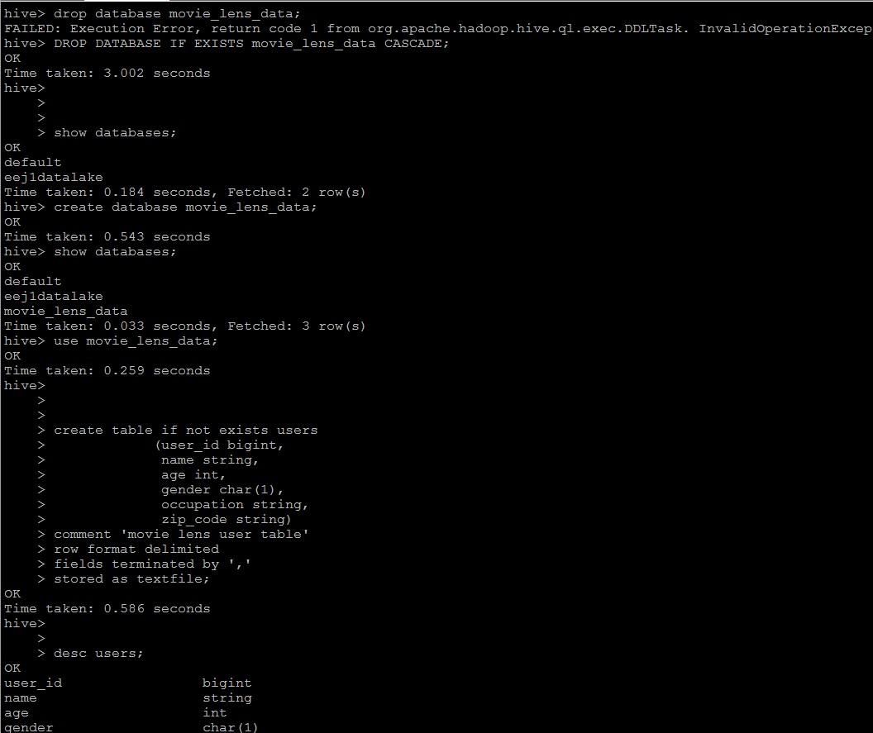

**Create Movies Table:**

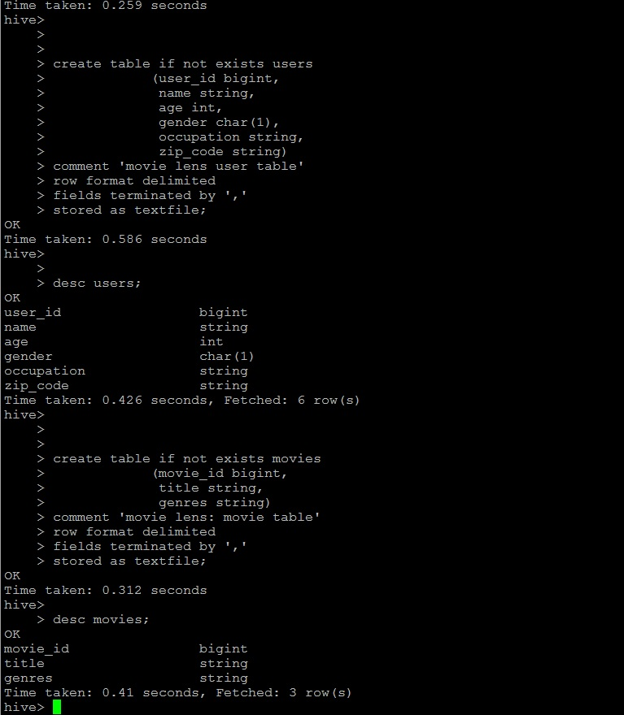

**Create Ratings Table:**

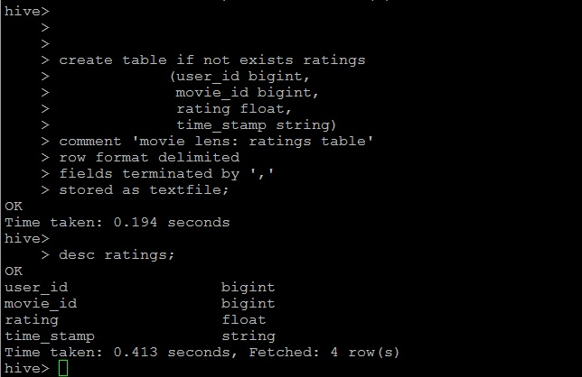

**Load Data to HDFS:**

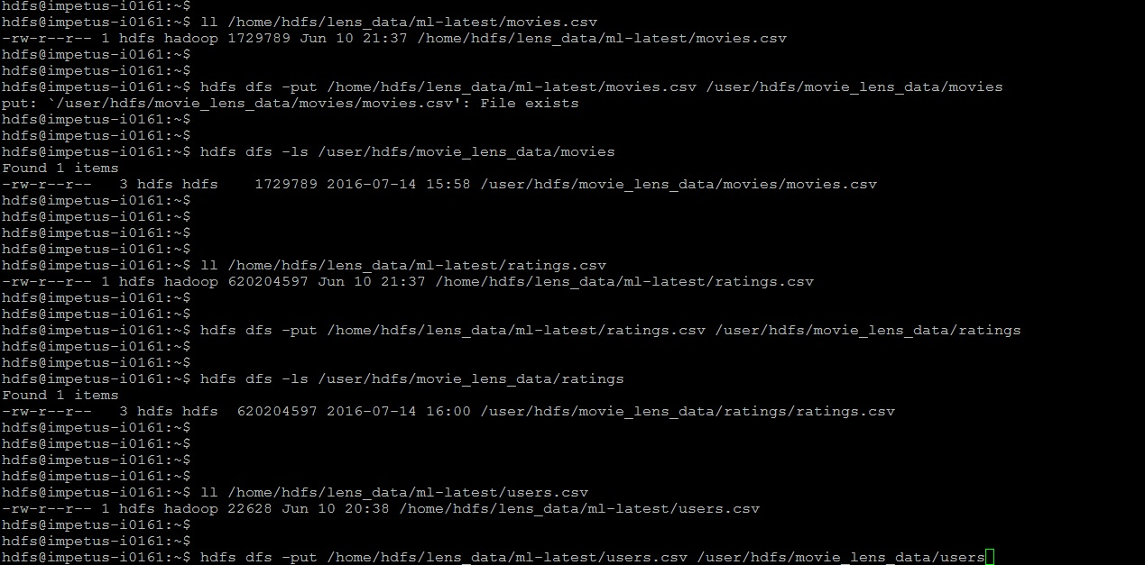

**Movies Count Verification:**

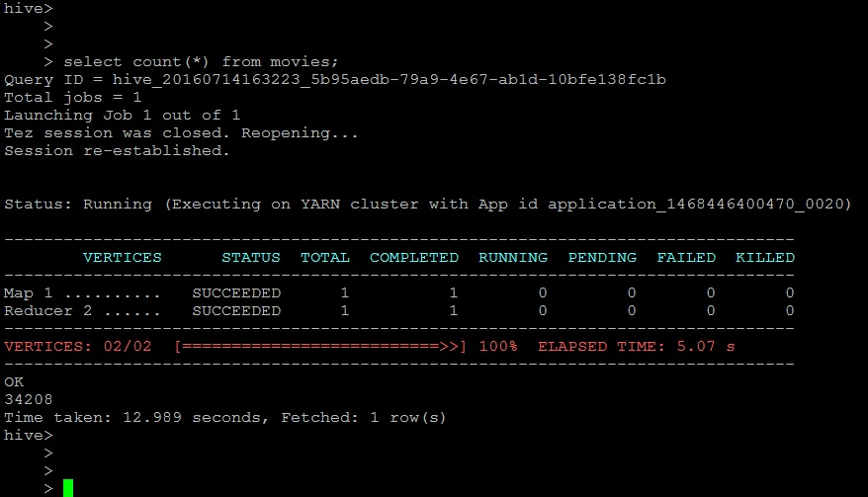

**Ratings Count Verification:**

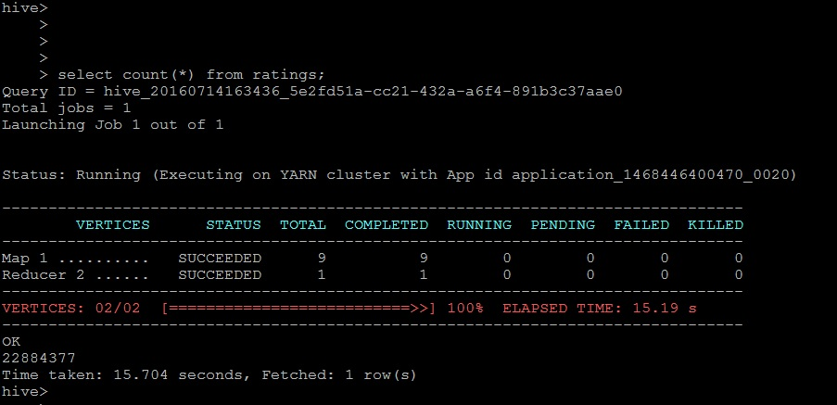

**Users Count Verification:**

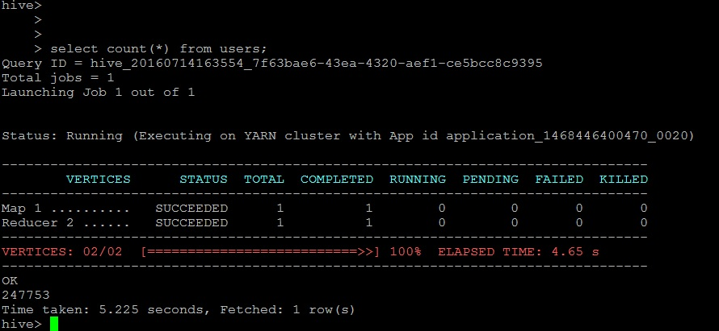

**Use Case #1: List all the movies and the number of ratings**

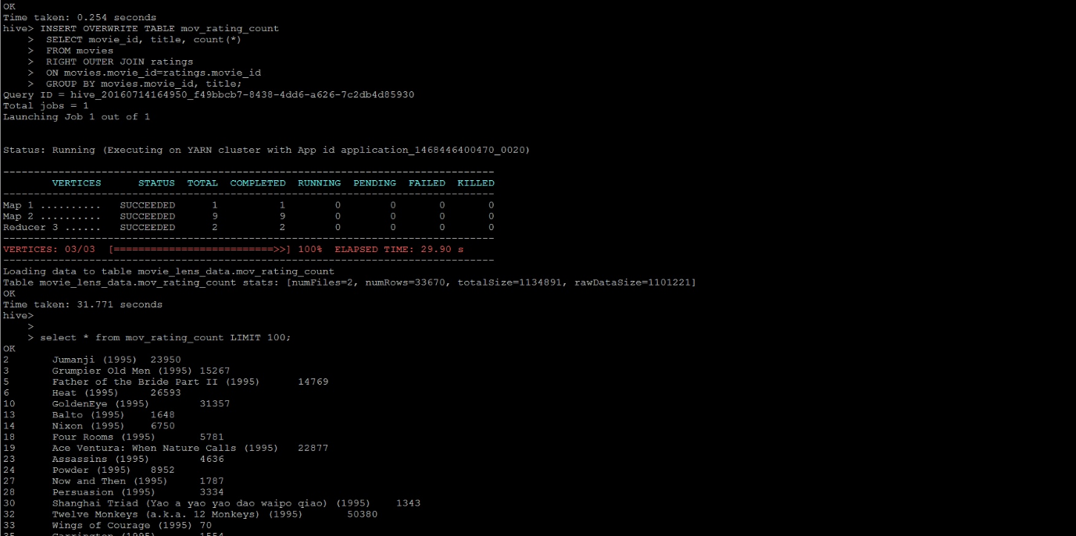

**Use Case #2: List all the users and the number of ratings they have done for a movie**

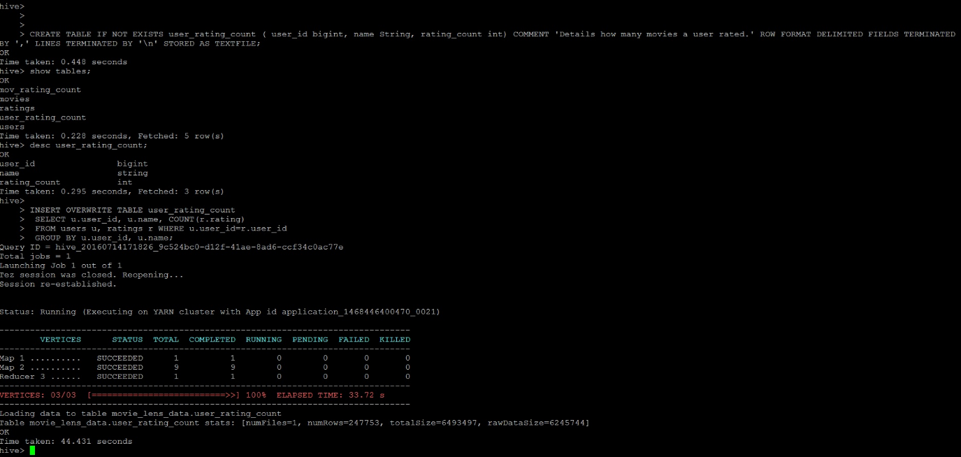

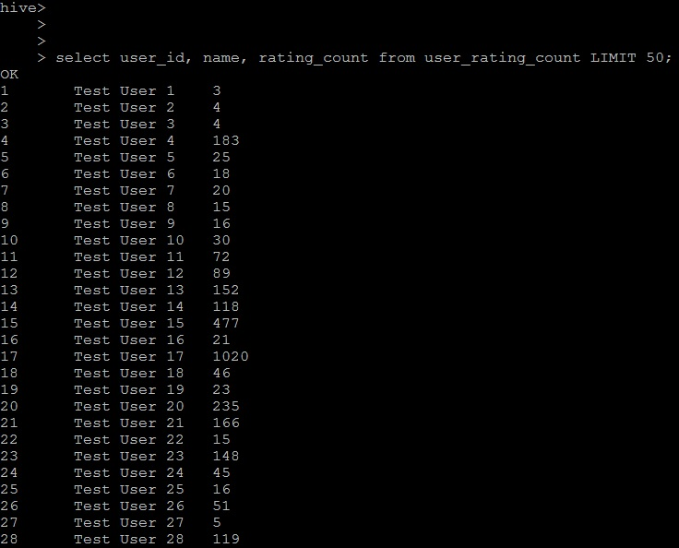

**Use Case #3: List all the Movie IDs which have been rated (Movie Id with atleast one user rating it)**

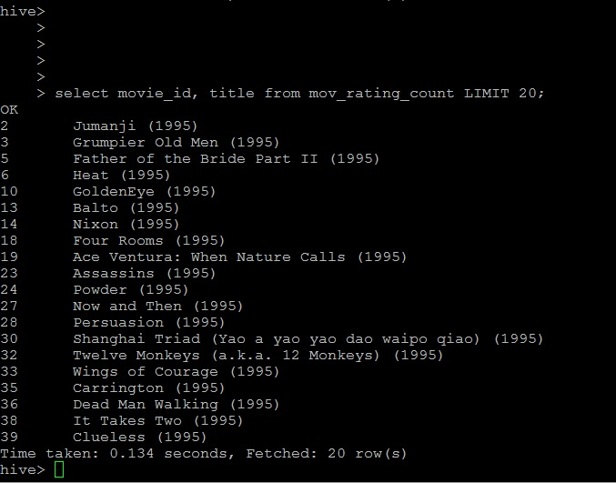

**Use Case #4: List all the Users who have rated the movies (Users who have rated atleast one movie)**

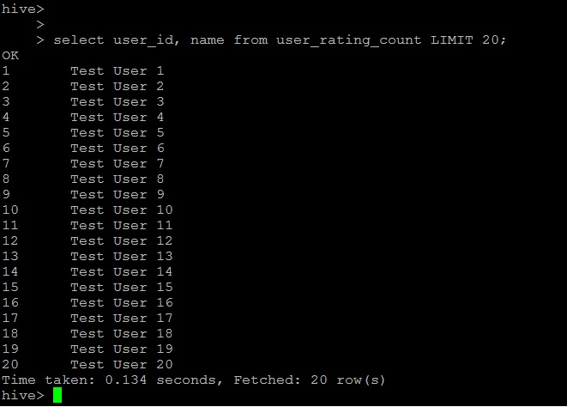

**Use Case #5: List of all the User with the max,min,average ratings they have given against any movie**

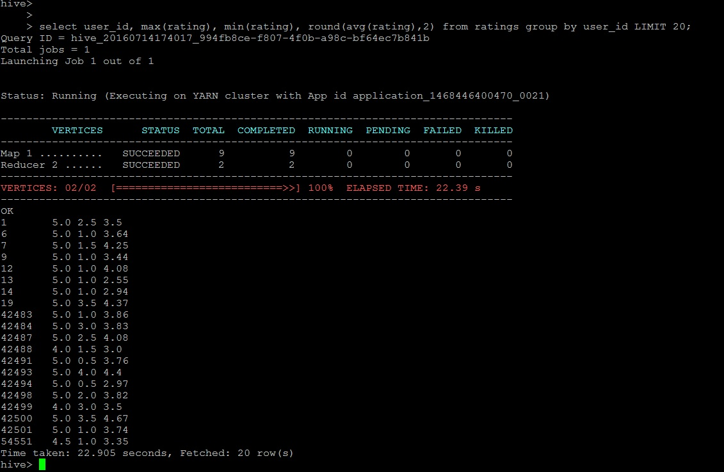

**Use Case #6: List all the Movies with the max, min, average ratings given by any user**

